AP Lab 5 - SKIN Name(s): ____________________________________________________
Block: _________ Table: _______ ___________________________________________________

Act. 1: Label the Diagram using the terms on the left of the diagram. Label the different skin locations for each of the 3 sections of skin. Then examine the Skin Model to be sure you can identify the same listed structures on a Model or Image. If instructed, point out the structures to your instructor on a Model or Image.
Epidermis:  - Stratum basale  - Stratum Spinosum  - Stratum Granulosum  - Stratum Lucidum  - Stratum Corneum  Dermis:  - Papillary Layer of Dermis  - Reticular Layer of Dermis  - Sweat Gland - (Eccrine/Merocrine)  - Sweat Gland - (Appocrine/Scent)  - Sebaceous Gland  Hypodermis:  Hair Follicle  Hair Shaft  Hair Root  Hair Papilla  (Dermal Papilla) | 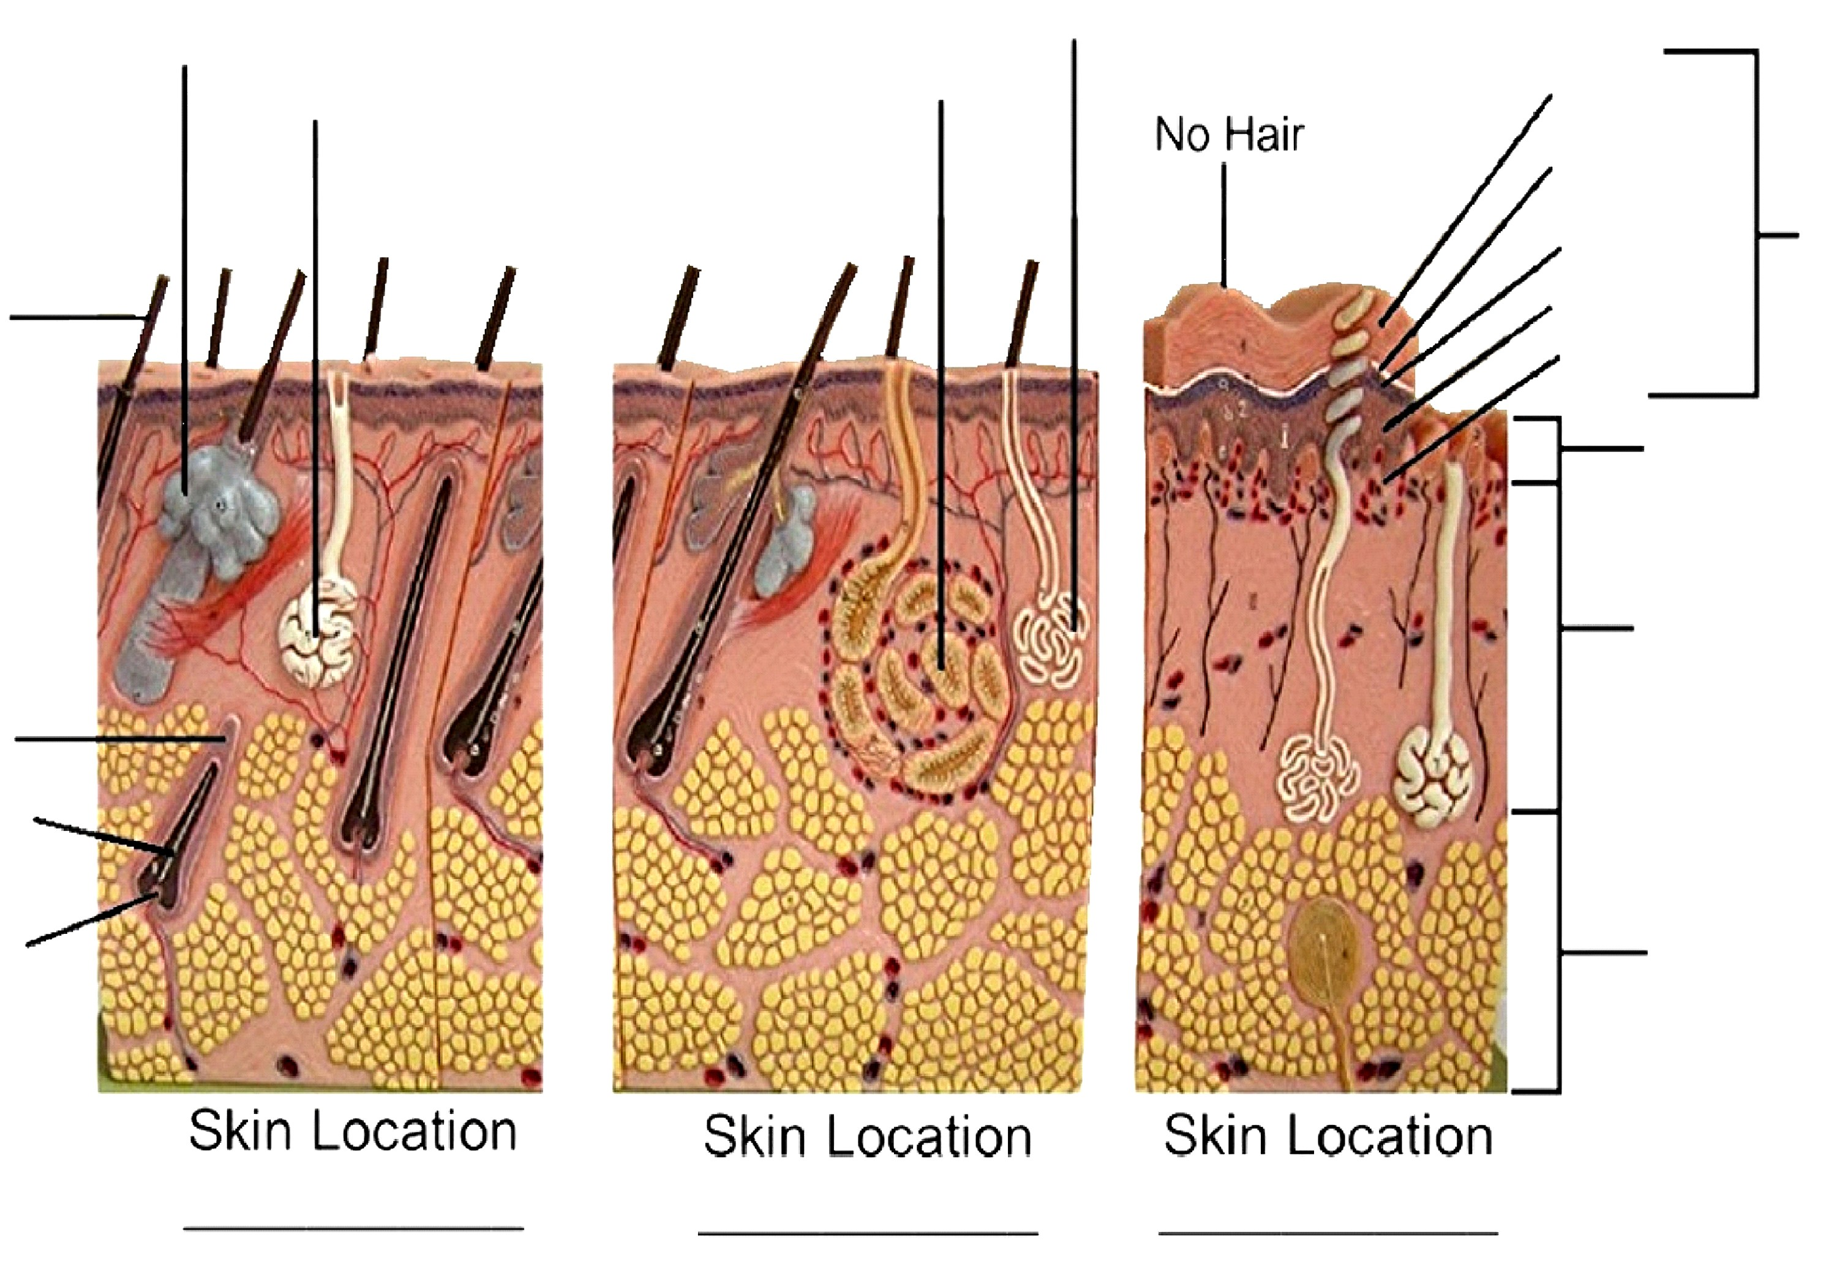  Note: Also point to Highlighted Terms on Next Page

Act 2: Label the Diagram using the terms on the left of the diagram. Then examine the Skin Hair Model or a Chart/Image to be sure you can identify the same listed structures on the Model or a Chart/Image. If instructed point out the structures to your instructor on the Model or a Chart/Image.
Epidermis:  Dermis:  - Dermal Papillae  - Sweat Gland  - Sebaceous Gland  Hypodermis:  - Adipose Tissue  Hair Follicle  Hair Shaft  Hair Root  Arrector Pilli Muscle  Meissner's Corpuscle  Pacinian Corpuscle | 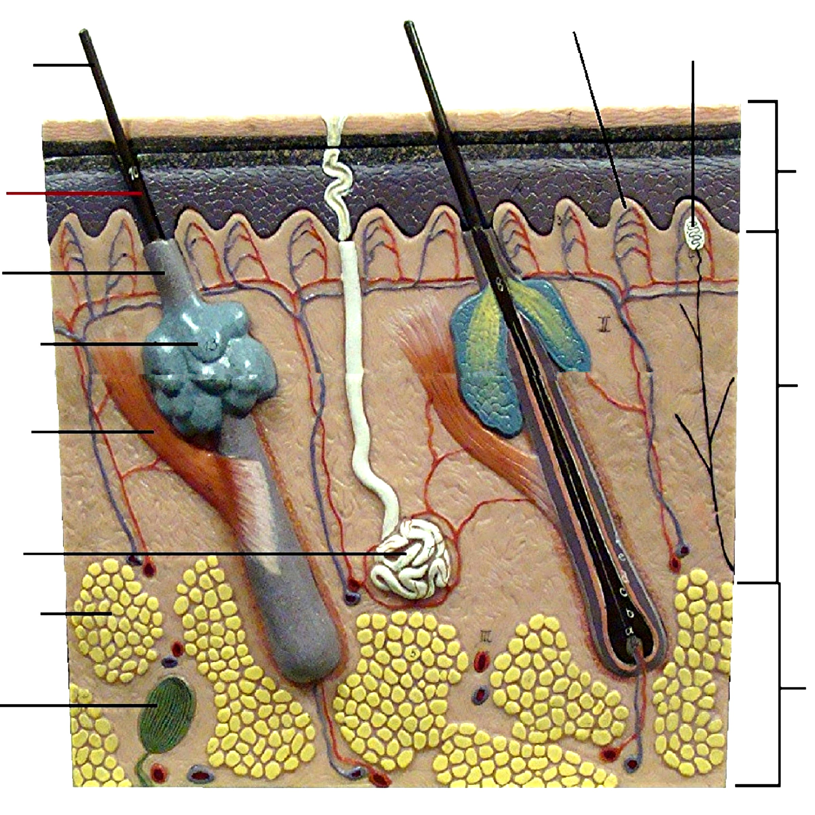

Act 3A: Skin Histology – Thick Skin
=’s Show on Slide
Upper Row: draw a microscopic representation of the listed structures.
Lower Row: paste an image(s) you have taken throught the Microscope showing the listed structures.
Use All the listed terms to label the structures in both rows
Epidermis (Bracket):
- Stratum Basale
(Germinativum)
- Stratum Spinosum
- Stratum Granulosum
- Stratum Lucidum
- Stratum Corneum
  - Sloughing Keratin

- Epithelial (Rete) Peg

Dermis (Bracket):
- Papillary Dermis (Bracket)
- Reticular Dermis (Bracket)

- Dermal Papilla

Act 3B: Skin Histology – Thin Skin - Pigmented
=’s Show on Slide
Upper Row: draw a microscopic representation of the listed structures.
Lower Row: paste an image(s) you have taken throught the Microscope showing the listed structures.
Use All the listed terms to label the structures in both rows
Epidermis (Bracket):
- Stratum Basale - Pigmented

- Stratum Spinosum
- Stratum Granulosum
- Stratum Corneum
  - Sloughing Keratin

Dermis (Bracket):

Act 4: Skin Hair Histology
Upper Row: draw a microscopic representation of the listed structures.
Lower Row: paste an image(s) you have taken throught the Microscope showing the listed structures.
=’s Show on Slide
Use All the listed terms to label the structures in both rows
- Hair Follicle
- Hair Root
- Hair Matrix
- Hair Shaft
- Dermal Papilla (Hair)

- Epidermis (Bracket)
- Dermis (Bracket)

- Sloughing Stratum Corneum Cells

- Sebaceous Gland

Act 5: Low-frequency Vibration / Fine Touch – Light Pressure Receptor
=’s Show on Slide
Upper Row: draw a microscopic representation of the listed structures.
Lower Row: paste an image(s) you have taken throught the Microscope showing the listed structures.
Use All the listed terms to label the structures in both rows
- Meissner's Corpuscle

- Epidermis (Bracket)
- Epidermal Rete Peg

- Dermis (Bracket)
- Dermal Papillae
(Not assoc'd c Hairy
Skin)

- Fingerprint Ridge

Act 6: How-frequency Vibration / Deep Pressure Receptor
Upper Row: draw a microscopic representation of the listed structures.
Lower Row: paste an image(s) you have taken throught the Microscope showing the listed structures.
=’s Show on Slide
Use All the listed terms to label the structures in both rows
- Pacinian Corpuscle

- Dermis (Bracket)

- Hypodermis (Bracket)

- Adipose Tissue

