A&P – Lung Physiology ONLINE Lab Names: _______________________________ Group #: _____

RESPIRATORY PHYSIOLOGY LAB
PRE-LAB WORK
- Before starting on the Lab, students should watch the following 2 Videos (located on the teacher’s website).:
  - Bell Jar Description of the Lungs
  - Lung Simulation Model AP2
VIDEO ASSIGNMENT
- Before labeling images on the Lab Form, create a Video pointing out and stating the Name of each the Specified terms.
- Your Video may contain both Still Images & Video Clips. Make sure the pointer is touching the structure you are naming as you narrate.
LAB FORM
- After making the Video, hand-write Labels and use leader lines (or Arrows when specified) attached to the labels to point out each of the specified terms or processes.

Activity 1: Lung Bottle Model (Bell Jar Lung Model) - Below are images of a Bell Jar Lung Model:
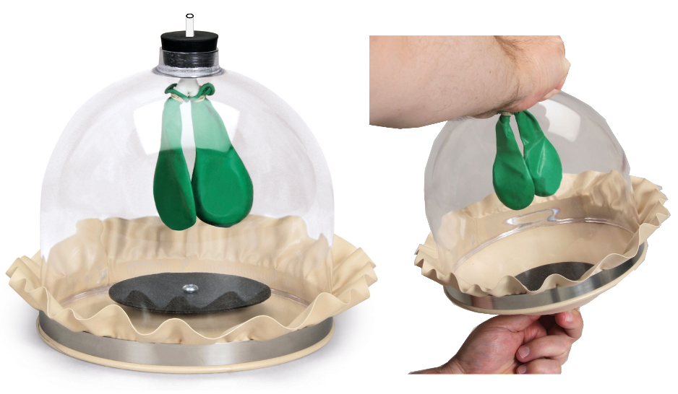

In this model, (Fill in the Blanks & then Label these Terms on the
above Diagram after pointing to them in the Video)

the straw or tube going down
to the balloons acts as the ___________________

the balloon(s) inside the bottle acts as the ___________________

the stretched balloon or rubber on
the bottom of the bottle acts as the ___________________

the inside of the bottle acts as the ___________________

the bottle itself acts as the ___________________
Activity 2: Lung Bottle Model (Bell Jar Lung Model) - Below are diagram images of a Bell Jar Lung Model

Below each Diagram, Label (& state in the video) which diagram represents INFLATION and which diagram represents DEFLATION. Below each Diagram, Label (& state in the video) whether the Diaphragm is CONTRACTED or RELAXED.

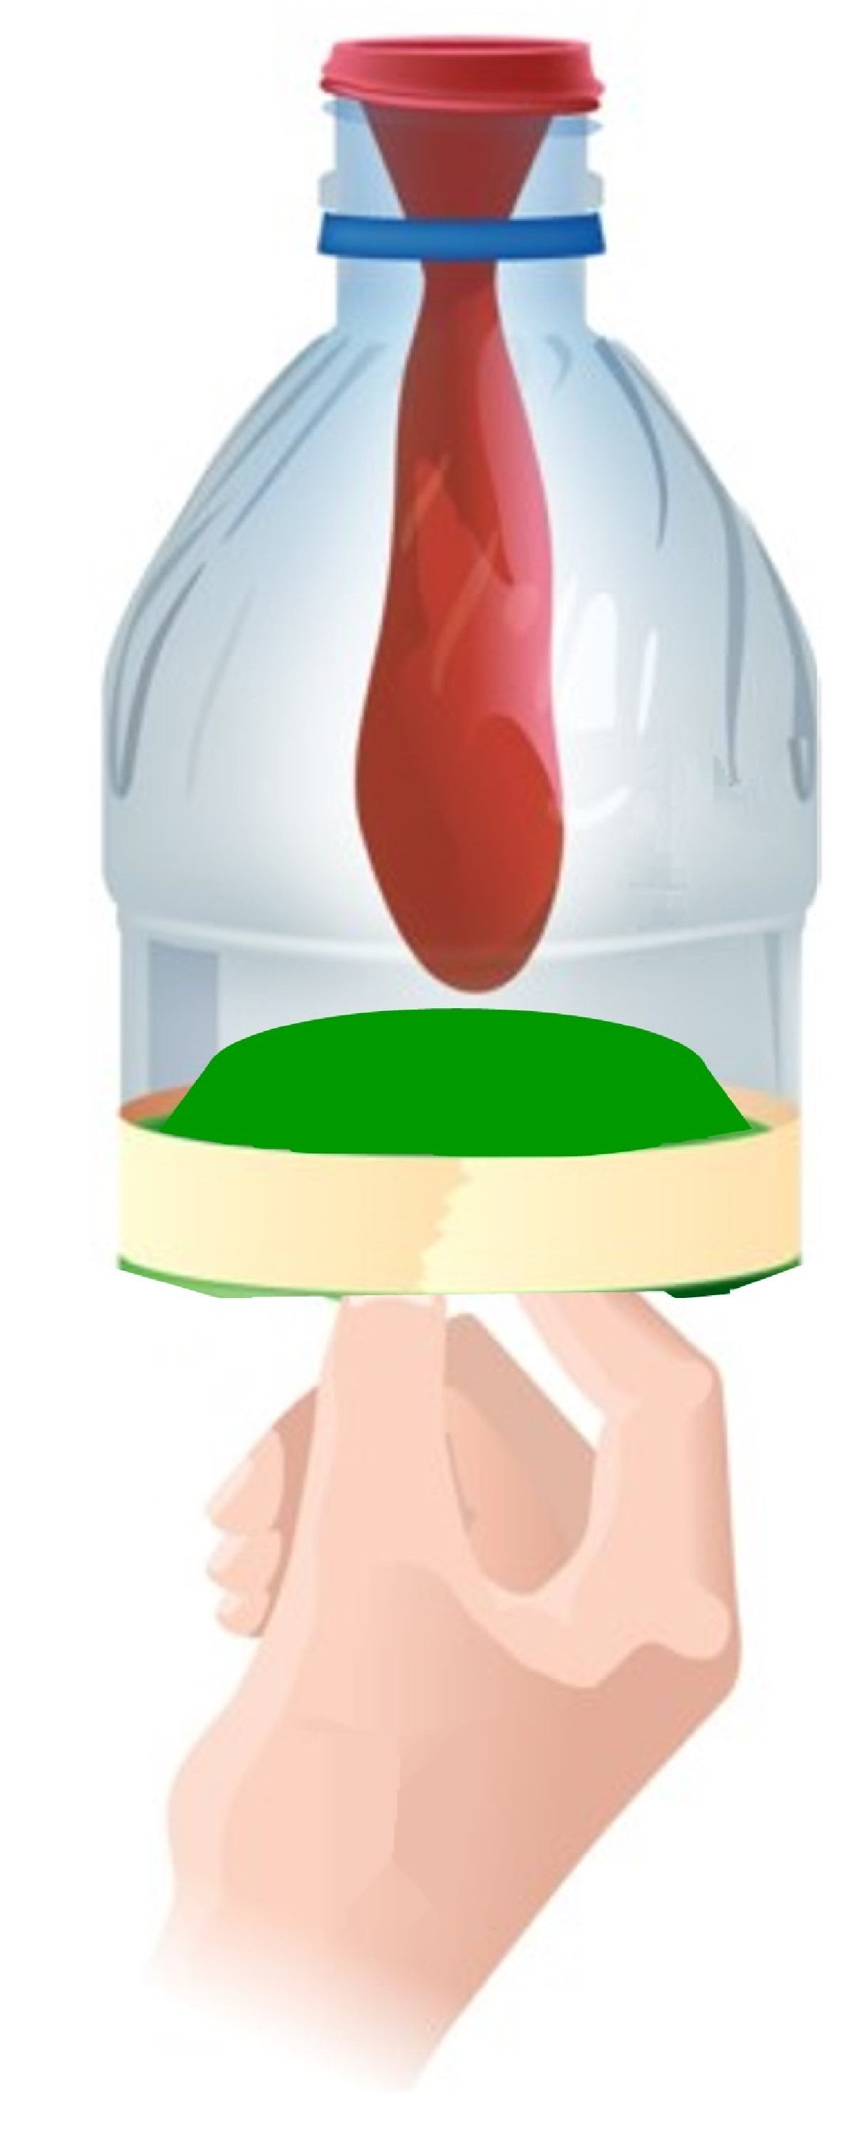
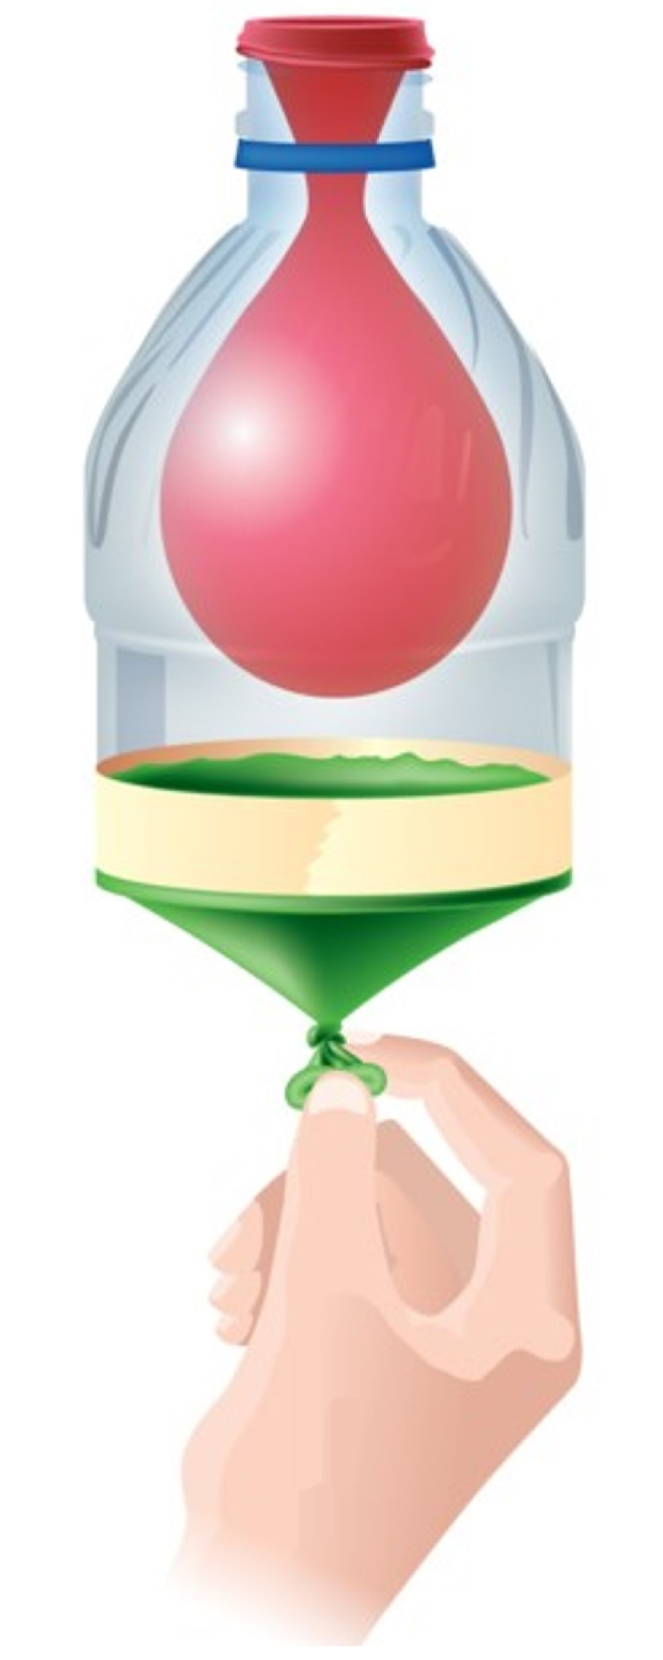

Label the following on EACH Diagram after pointing out the terms in the Video:

- Atmosphere

- Chest Wall

- Diaphragm

- Lung

- Thoracic Cavity

- Trachea

Place an ARROW above each Bottle (before making the Video) showing the Direction of Air Movement & Label the arrow as AIR INFLOW or AIR OUTFLOW. (Be sure to state this in the Video as well).

Activity 3: Lung Bottle Model (Bell Jar Lung Model) – Physiology Questions
(Show the Appropriate Unlabeled Image from Activity 2 when Dictating each section below in the Video)

When you pull down on the rubber on the bottom of the jar, the volume inside the bottle
_____________ (incr's/decr's). This _________ (incr’s/decr’s) the air pressure inside the bottle
so it is ____________ (less/greater) than the air pressure outside the bottle. Air flows
from ___________ (high/low) pressure to __________ (high/low) pressure, so air flows
________ (into/out of) the straw/tube and __________ (inflates/deflates) the balloon.

When a person inhales, the diaphragm contracts and domes DOWNWARD making the volume of the chest cavity
________________ (incr/decr). Air from outside flows ___________ (into/out of) the airways
and _____________ (inflates/deflates) the lungs.

When you push up on the rubber on the bottom of the jar, the volume inside the bottle
__________ (incr's/decr's). This ___________ (incr's/decr's) the air pressure inside the bottle
so it is ____________ (less/greater) than the air pressure outside the bottle. Air flows
from ___________ (high/low) pressure to __________ (high/low) pressure, so air flows
__________ (into/out of) the straw/tube and ___________ (inflates/deflates) the balloon.

When a person exhales, the diaphragm relaxes and domes UPWARD making the volume of the chest
cavity
___________ (incr/decr). Air _________ (enters/exits) the lungs through the airways and
____________ (inflates/deflates) the lungs.

